DB Synchronizer
Detailed Design Document
Author: Kaliven Lee
Version: 1.0
Date: 2005-10-27

Contents
1 Introduction 5
1.1 Purpose 5
1.2 Scope 5
1.3 Definitions, Acronyms, and Abbreviations 5
1.4 References 5
1.5 Overview 5
2 Architecture 7
2.1 Architectural Goals 7
2.1.1 Retrieve data 7
2.1.2 Maintain Persistence 7
2.1.3 Other goals 7
2.2 Constraints 8
2.2.1 IDS API Constraints 8
2.2.2 Other Constraints 8
2.3 System Logical Structure 8
2.3.1 Overview 8
2.3.2 Architecturally Significant Design Packages [optional] 9
2.4 Error Handling and Fail-Over [optional] 10
2.5 Issues and Considerations (TBD) 10
3 Static Class View 12
3.1 DBSyncServ 12
4 DB Schema 13
4.1 EntryMDD and EntryMDSelect 13
4.2 Object and Object Metadata table 14
4.3 Relationship description table 15
4.4 Sequence define 15
4.5 Work queue 16
5 System Sequence View 17
5.1 Sequence Diagram 18
5.1.1 Sequence Diagram of Start Service 18
5.1.2 Sequence Diagram of Asset State Change 19
5.1.3 Sequence Diagram of Asset Metadata change 20
5.2 Program Flow Chart [optional] 21
5.2.1 ObjectStateCallBacks 21
5.2.2 FolderCallBack 22
5.2.3 ObjectMDCallBack 23
5.2.4 CaCallBack 23
5.2.5 MDCallback 24
5.2.6 SaveEntriesToDB 25
5.2.7 SaveElementsToDB 26
5.2.8 UpdateAll 27
5.2.9 SaveOneComplexAsset 28
5.2.10 SaveOneFolder 29
5.2.11 SaveOneAsset 30
5.2.12 SaveOneHierarchy 31
5.3 Program State Diagram [optional] 31
6 Configuration 32

Revision History
Version | Revise Date | Owner | Notes
1.0 | 2005-5-30 | Kaliven Lee | Document created, include:
1.1 | 2005-10-27 | Bernie Zhao | Added timewindow new feature

Introduction

Purpose
DB Synchronizer is a core service in the framework of the NGN of ZQ. For the history cause, multiple language support and performance, ZQ applications use own DB Server which independency on ITV System. However ZQ applications are based on the SeaChange VOD system. So the data in ZQ DB must be consistent with VOD System. DB Synchronizer service will retrieve the media information from VOD system to ZQ DB and keep it synchronization with VOD System.

Scope
DB Synchronizer replicates the data of the SeaChange VOD System to the ZQ DB. DB Synchronizer will maintain the map of the SeaChange defined object in IDS DB and keep the persistent with the SeaChange VOD System and ZQ System.

Definitions, Acronyms, and Abbreviations
Name | Description.
IDS | SeaChange Interactive Directory Service
IAM | SeaChange Interactive Asset Manager Service
DBSync | ZQ DB Synchronizer Service

References
[R01] DB Synchronizer detail doc
[R02] DB Synchronizer work queue detail.doc

Overview
SeaChange Database Synchronization Service is a part of ZQ solution to maintain media information based on SeaChange VOD System. DBSync will synchronize the media information from SeaChange IDS DB to ZQ DB. So that ZQ applications can use such information directly without affecting the performance of ITV CC. And any change of media on ITV System will be triggered to ZQ DB.
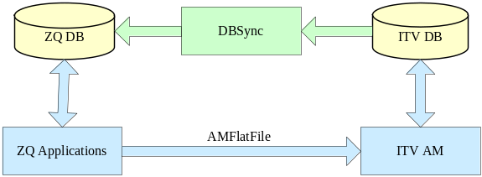
Figure I
Usually in the ZQ solution based on SeaChange VOD System as Figure 1, ZQ Application will send an AMFlateFile to ITV AM.ITV System will parse the file and take the change as AMFlateFile do. And this action soon will take affect on ITV DB. And DBSync will get such trigger and make same change on Local ZQ DB from IDS Service. And DBSync will maintain the map relationship between ZQDB and ITVDB.
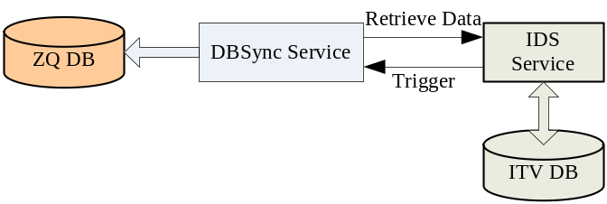
Figure 2

Architecture

Architectural Goals

Retrieve data
Retrieve media information from SeaChange IDS DB and storage it into ZQ DB.
- Get ITV Object information including ID, name and other fields of Site, Application, Folder, Asset, AtomicElement ,clip and metadata description .
- Get the metadata of ITV Objects including Site, Application, Folder, Asset, AtomicElement , clip and metadata description.
- Get relationship between ITV Object include hierarchy (Media Tree) and CoplexAsset (Asset Composition).

Maintain Persistence
Maintain the persistence of the data in IDS DB and ZQ DB.
- When DBSync is running, any operation done to change the information in VOD system, ZQ DB should make the same change according to the callback.
- If DBSync is stopped, it can not synchronize the change in IDS DB. But if it restarts, it can renew the data in ZQ DB.
- If a change happened in SeaChange VOD System, DBSync should insert a record into work queue in the ZQ DB. If any ZQ application is interested in the change, it will scan the work queue and react to the change.

Other goals
- From the view of extensibility, DBSync should be packet and installed as standard SeaChange service.
- If fatal error coming, DBSync should be able to restart to restore the environment.
- Synchronize specified directory. In some case, DBSync only need to synchronize the specified directory.
- DBSync is responsible for notify Navigation synchronization with some strategy optimizations.
- DBSync will generate xml files to notify Ingest Manager or Program Manager the certain asset element state changes (such as from inactive to active).

Constraints

IDS API Constraints
DBSync is based on the IDS Client API. So the function and architecture are constraint by IDS API.
- In some cases, if call IDS API in call back, there will be a deadlock. DBSync should throw a thread to call the IDS API in IDS callback.
- One operation on IAM will trigger series callbacks one after one in the IDS client. The sequence is decided by IDS Architectural. And in some cases, the sequence is not reason for the logic of DBSync.

Other Constraints
- When DBSync start, it does not know which media had been deleted during the process of stop. Though DBSync can use a flag to show which one is still in VOD system and then after finish start DBSync will delete these media, there still a long term interval for deleted media to exist in the system. This dirty data in some sense is unavoidable under the architecture of IDS.
- The Schema of ZQ DB is different with the Schema of SeaChange IDS DB. And the data structure of callback is also different with the schema of ZQ DB. So DBSync should organize the data from IDS API or call back and inject it into ZQ DB. And it is usually time-cost. Performance should be reconsidered in the next version.

System Logical Structure

Overview
DBSync is mainly composed by DSInterface, DBInterface, Main Logic and SeaChange Service shell. DSInterface encapsulates the IDS API and callback. And all the map and synchronization logic are in the module of main logic. For the historical causes, DSInterface is mixed with main logic. DB interface is an ODBC encapsulation. Main logic can access the ZQ DB directly by DB interface. SeaChange service shell is a template of standard SeaChange services so that DBSync can inherit the character of SeaChange service.
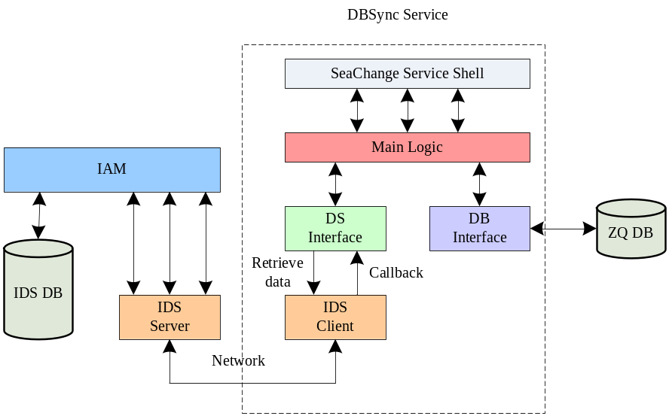
Figure 3 Logic structure of DBSync

Architecturally Significant Design Packages
1. Main logic – callback processing
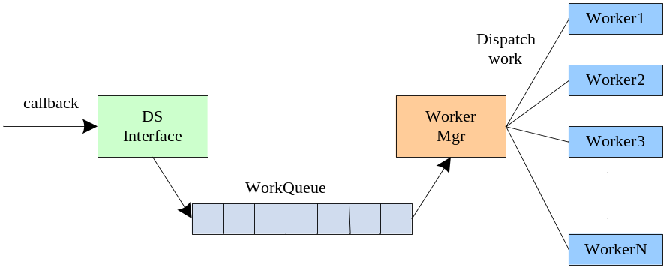
Figure 4 callback processing structure
As it was said in constraint, when processing some callback, DBSync will call IDS API to get some detail information. And it will cause dead lock. So DBSync should open thread to process the task. If lots of this type of callback coming, a single thread can not process such jobs at once. So multiple-threads structure should be introduced into the DBSync as figure 4. When DS interface receive a IDS trigger and this callback should be processed by other thread, DS Interface will insert a new task into the work queue. WorkerMgr is a single thread which manages the multiple worker thread. It will scan the work queue, pop the task and dispatch the task to worker thread.
2. Main logic -- IDS connection checker
A checker will run to check the connection to IDS Server interval. If the connection is break, the checker will try to connect to the IDS Server. And if the connection is resumed, the checker will restart DBSync to restore the data.

Error Handling and Fail-Over [optional]
- IDS Connection break
If IDS connection is break, a callback of IDS will be triggered. DBSync will write the message to event log and file log. And checker will try to reconnect to the IDS Server. If the connection is resumed, DBSync will restart to restore the data.
- SQL Server connection is break
If SQL server is stopped, DBSync will block the main logic and try to reconnect the SQL server. If the connection is resume. DBSync will restart to restore the data.

Issues and Considerations (TBD)
- DBSync is a client encapsulation for IDS API. But it was bind with ZQ DB. And the ZQ applications which usually are java applications can not get the trigger message real time. And more and more requirement will come to require DBSync to inform other application. It will cause DBSync more and more complex. An efficiency way is to separate the IDS interface with the detail logic. And only encapsulate the IDS API as a jar for JAVA application to call. If any application is interest in the change of media information, it can inherit the jar and implement its own logic. So that Java application can get real time trigger and design the logic according to its own requirement.
- Performance of DBSync also should be considered. Currently it will cost DBSync 1 hour to restart when the site has 2000 assets. With the new application was introduced into the VOD system, there will be more asset in the VOD System such as music and game application.
  - Server side load
For the sake of extensibility, IDS DB is created dynastically. Each metadata of each object has it own table. So if DBSync retrieve an asset’s metadata, server side will almost search in 50 tables to get the data. So usually when DBSync restart the load of CC box will be high. And because CC box also receive the DMSCC command, if the CPU usage of CC box is up to very high value, it will cause CC box to reject any DMSCC request. Maynard send a patch to us so that client can get the information of a group of media. But in some requirement, DBSync should be able to only synchronize the media under specified path. So we still do not implement logic with such patch.
  - Client performance
For the history cause and language character, DBSync do the main logic. And because ODBC access is slow in C++, the performance of DBSync is low. An effective way is to separate the logic from DBSync to ZQ DB as storage procedure. So that the logic can be process more quickly and the complex of DBSync can be reduced.
- For the historical causes, if exception happened, DBSync hardly can restore the environment. The only way is to restart the service. But the restart process will result in some dirty data in local ZQ DB. It seems a dilemma for DBSync.

Static Class View
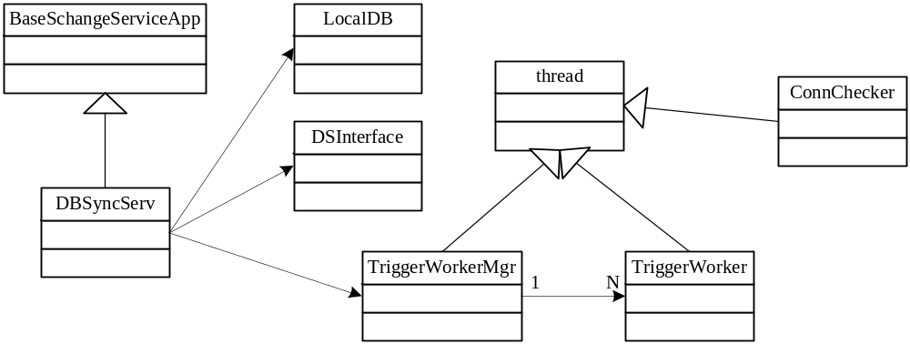

DBSyncServ
DBSyncServ inherits from BaseSchangeServiceApp which is a standard SeaChange Service encapsulation. DBSync inherits SeaChange Service shell so that DBSync can work as a standard SeaChange Service. It will compose LocalDB as an ODBC encapsulation, DSInterface as an IDS encapsulation and TriggerWorkMgr as a thread manager.
- LocalDB
LocalDB is an encapsulation for ODBC. It should offer SQL execute, transaction operation and exception handle.
- DSInterface
DSInterface encapsulate the IDS API and DB map logic.
- TriggerWorkerMgr
A single thread to manager the worker thread life cycle. Scan the Work queue and dispatch the task to the idle worker.
- TriggerWorker
Thread to process detail callback. Accept the task from worker manager.
- ConnChecker
A thread check the ids connection time to time.

DB Schema

EntryMDD and EntryMDSelect
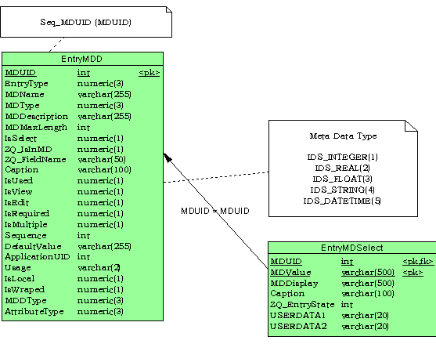EntryMDD table describes objects’ metadata. And if the metadata has optional selection value, isMultiple of EntryMDD will be set as 1, And EntryMDSelect will describe the selection display, Selection value. UserrData1 and UserData2 in EntryMDSelect describe detail information of each selection. Currently these fields only used for Metadata VCRCommandCharge and ServiceCode.UserData1 describe the price and UserData2 for tax. The data is retrieved from the structure below:
typedef struct _IZQ_PRICE_STRUCT {
unsigned char version[8]; // Not sure about first 8 bytes, first 2 bytes wa version, not any document about 6 bytes following.
double price; // Price value of a category
double tax; // Tax value of a category
} IZQ_PRICE_STRUCT;
For the historical cause, MDUID is not same as the mduid in IDS DB. And the MDUID below 2000 will keep stab. Each time DBSync restart it will remove all the metadata record in EntryMDD and EntryMDSelect where MDUID is bigger than 2000. And if DBSync find a new metadata when restart it will insert a new record in EntryMDD and EntryMDSelect.

Object and Object Metadata table
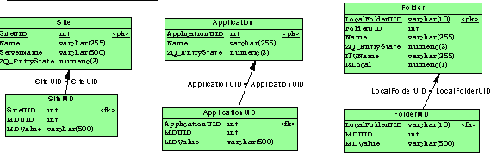
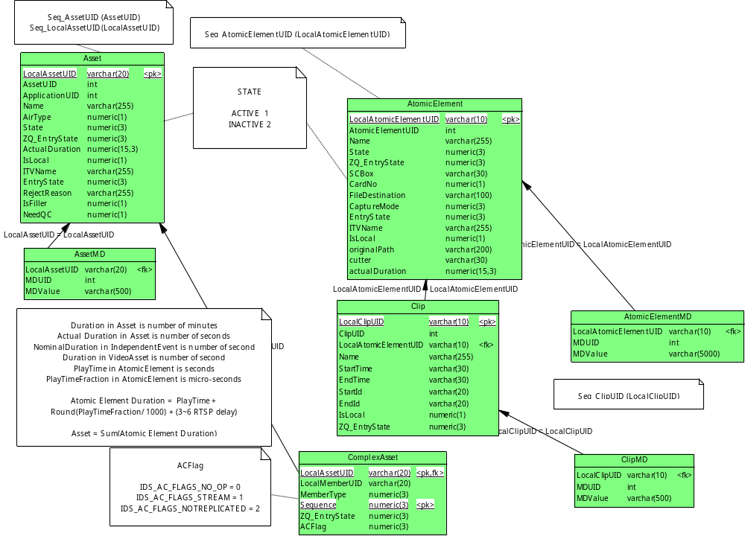
In ZQ DB, There are several object tables to describe the object in IDS DB. There are Site, Application, Folder, asset, atomicElement and clip. Object metadata table describe the metadata of these objects. Specially, Folder object do not exist in IDS DB, the Folder id is hierarchy ID in IDS DB. Some of the special metadata is set in the object table for application to get data easily.

Relationship description table
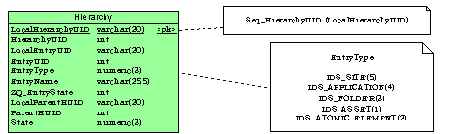
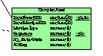
The hierarchy, complexasset and somehow clip described the relationship between these object. Hierarchy describes the media tree in DS DB as same as the am show. ComplexAsset describes the composition of Asset. An asset can be defined by a composition of assets and atomicelements. And Clip also define the clip is belong a specified atomicelement.

Sequence define
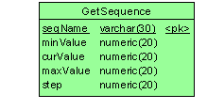
The LocalUID of object is built by DBSync. The sequence table record the current used LocalUID for each object. When DBSync need to build a new LocalUID it will get the current ID at first and then add it up 1 step as its new LocalUID. And If the CurValue is up to MaxValue, CurValue will be set as MinValue.

Work queue
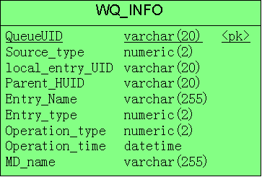
Because some of applications want to receive the IDS callback message, in some project, DBSync will insert record to work queue table. And application will scan the table time to time to get the record.
Because when DBSync restart lots of record will be inserted into the work queue. To reduce the work load of scan application, DBSync do not insert any record into the work queue when restarting. And if the DBSync finish the restarting, DBSync will insert a record with operationID 99. to inform the application that the ZQ DB is renewed.

System Sequence View

Sequence Diagram

Sequence Diagram of Start Service
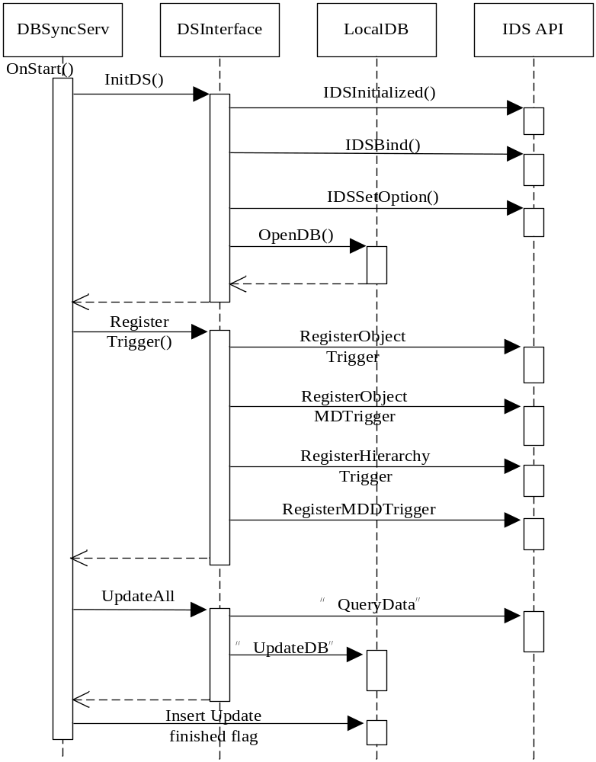

Sequence Diagram of Asset State Change
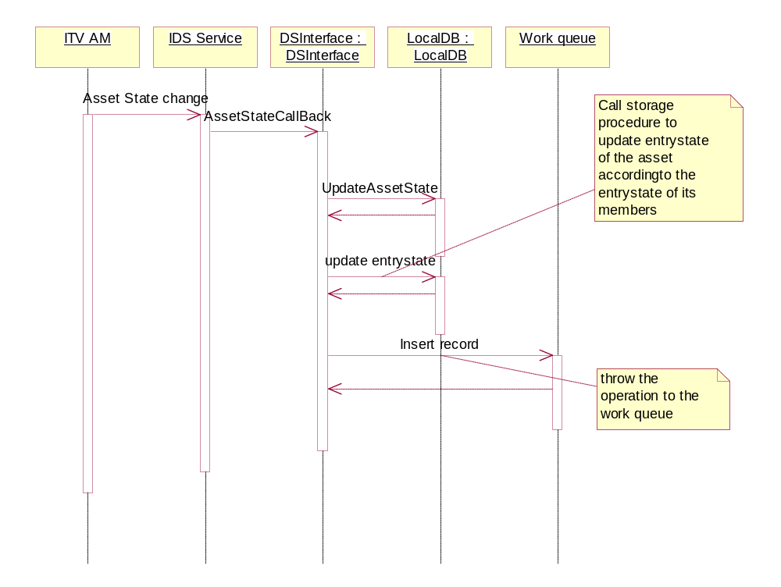
DBSync can sink the state change of asset and element. The diagram describes a general sequence of asset. And element state change will follow this sequence.

Sequence Diagram of Asset Metadata change
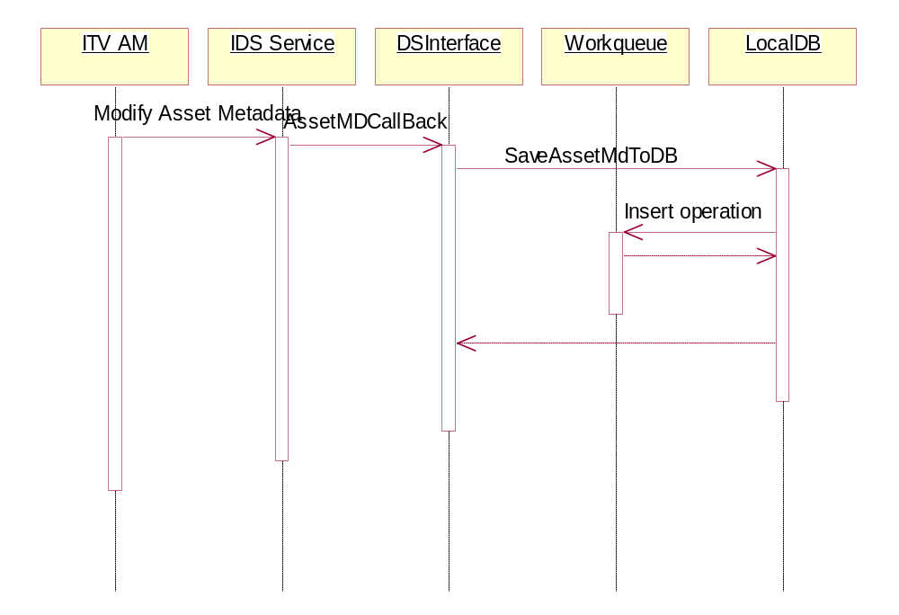
DBSync can sink the changes of the metadata of ITV object such as clip ,element, asset ,folder ,application and site. DBSync can get the operation and the new data of the metadata. DBSync updates, deletes or inserts the data to Local DB according the operation. And then insert the operation to Local DB. And the metadata of other object follow the sequence of as asset.
.

Program Flow Chart [optional]

ObjectStateCallBacks
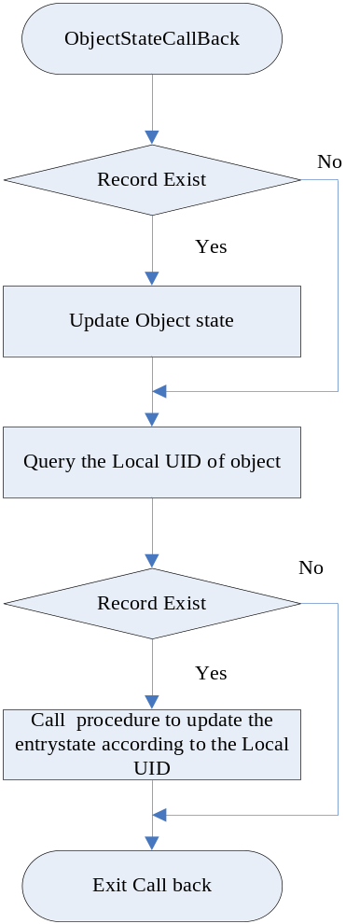

FolderCallBack
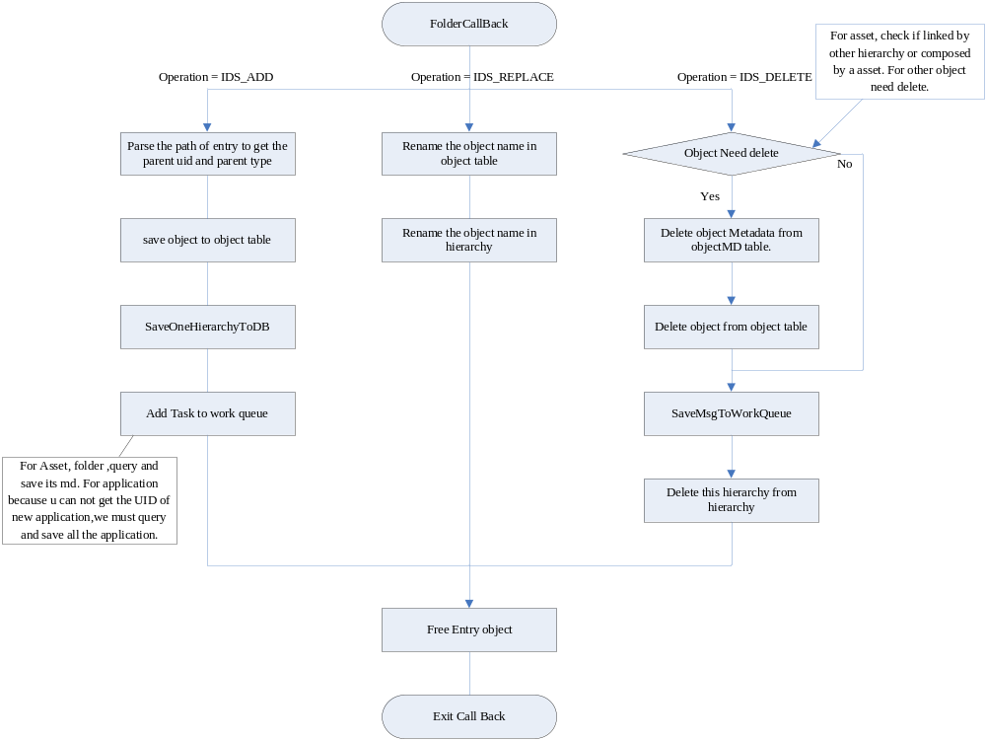

ObjectMDCallBack
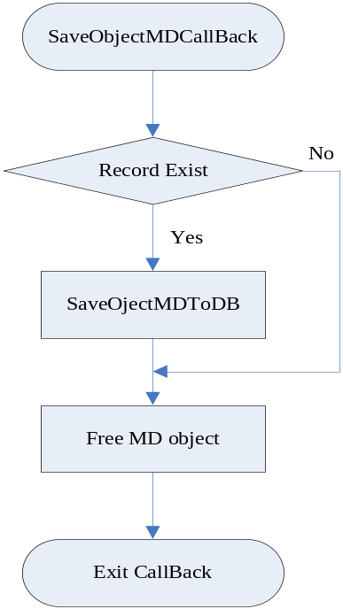

CaCallBack
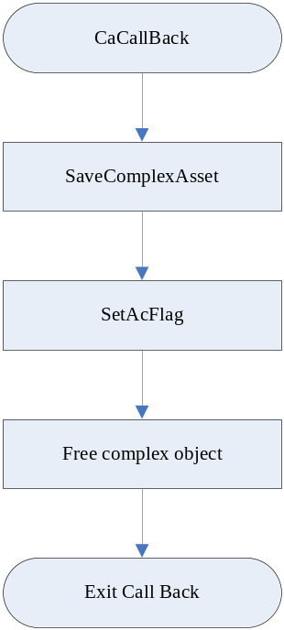

MDCallback
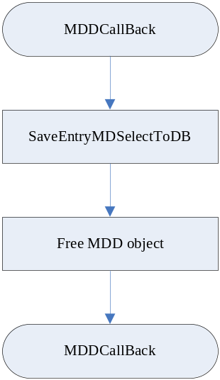

SaveEntriesToDB
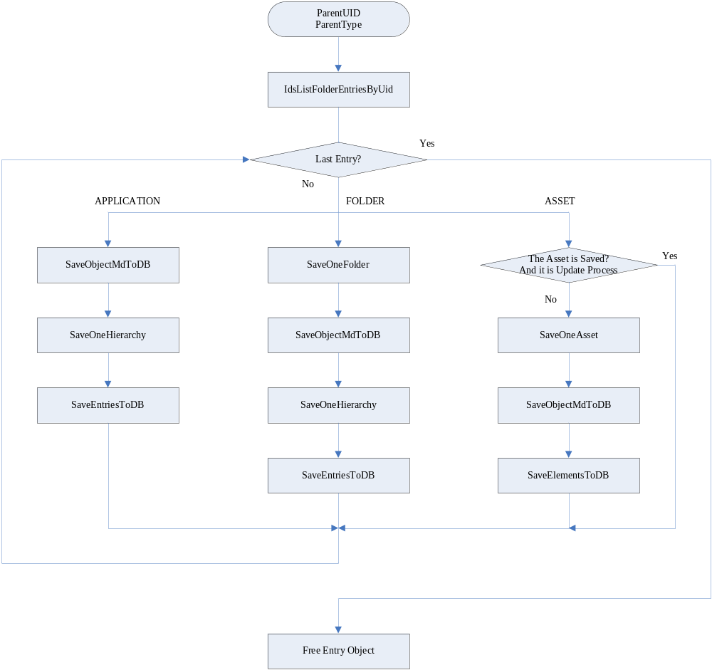

SaveElementsToDB
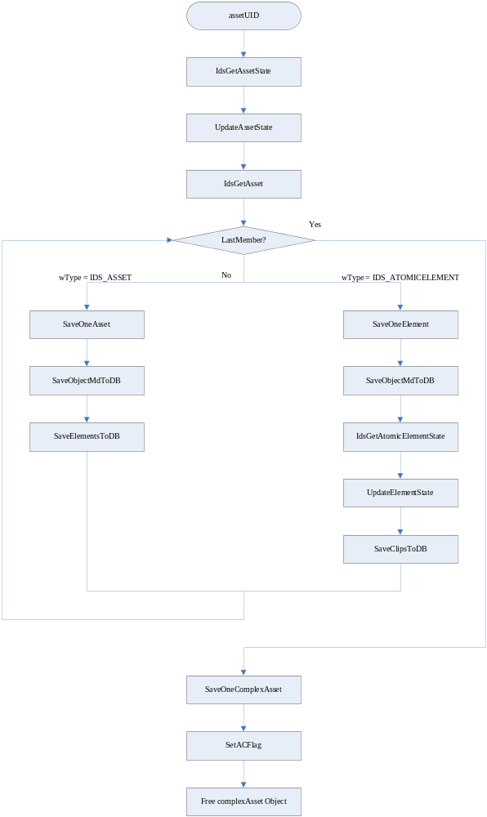

UpdateAll
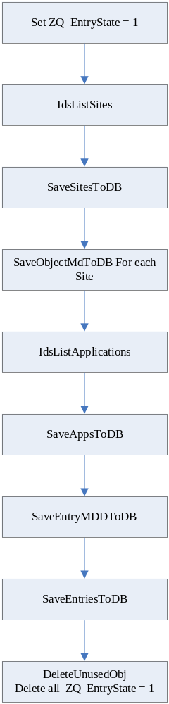

SaveOneComplexAsset
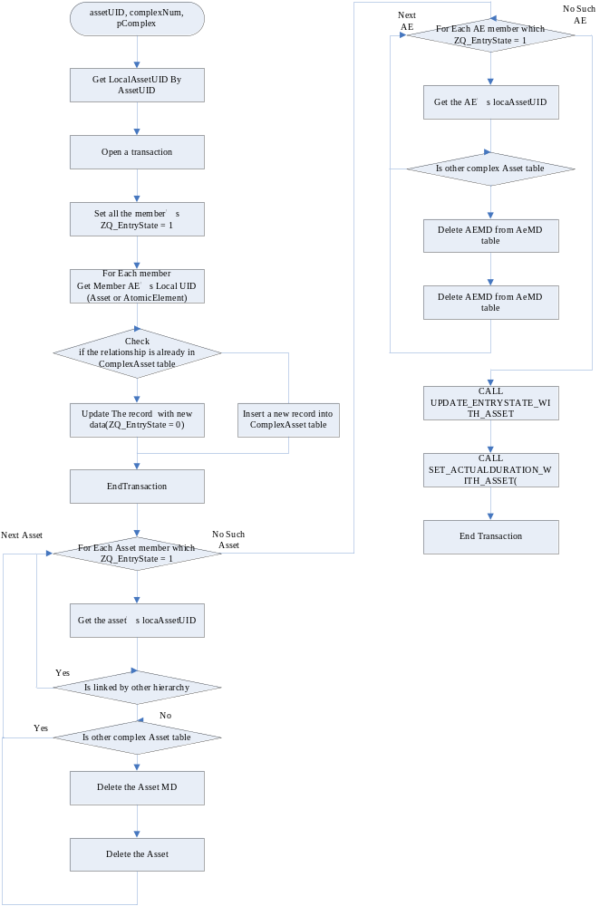

SaveOneFolder
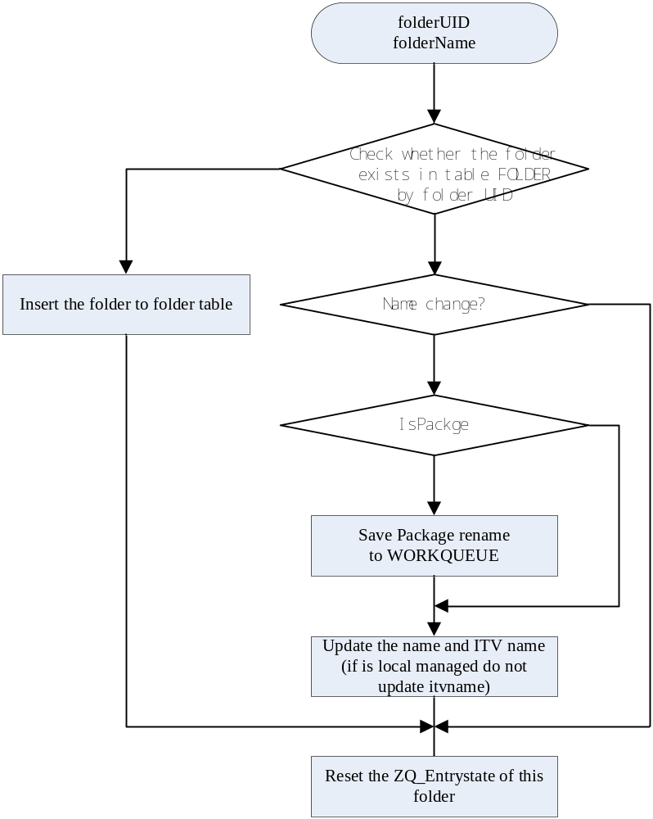

SaveOneAsset
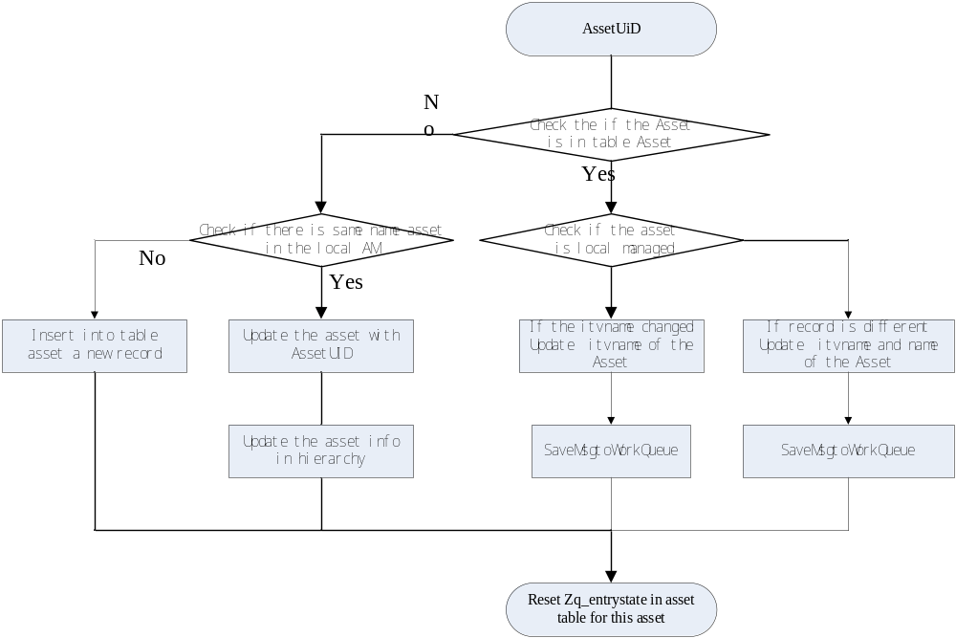

SaveOneHierarchy
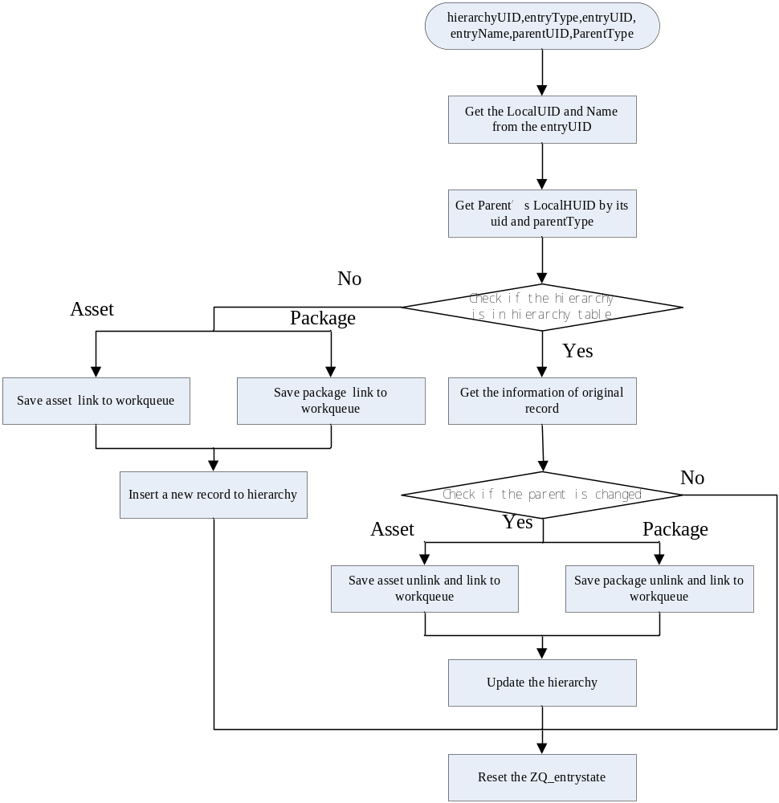

Program State Diagram [optional]
Draw the state diagram here if needed.

Configuration
DBSync read Configuration from OS register.
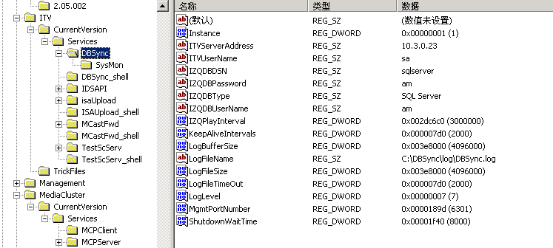
Installshield will set default value of the DBSync automatically.
HKEY_LOCALMACHINE\Software\Seachange\ITV\CurrentVersion\Services\
Configuration | Content | Default value
ITVServerAddress | IDS server Address | 10.3.0.23
IZQDBDSN | ODBC DSN of Local DB | sqlserver
IZQDBPassword | Local DB Password | am
IZQDBTYPE | Local DB type(SQL Server or Oracle) | SQL Server
IZQDBUserName | Local DB UserName | am
IZQPlayInterval | Local DB play interval | 3000000
LogLevel | 0(ERROR)-7(DEBUG) | 7
SyncDirectory | \Movie On Demonad | Specified directory to synchronize the objects.
TimeWindowThreshold | 600 | Time interval, in seconds, within which asset metadata ‘ActivateTime’,’DeactivateTime’ and ‘DeleteTime’ will not affect Navigation Synchronization.

Open Issues
- Multiple DB Support
DBSync plan to support sqlserver and oracle. But in recently version, DBSync add support to multi-language for sqlserver. And for SqlServer, SQL string should add ‘N’ before the input Unicode string. However it is invalid in Oracle. If the new version is about to release to support Oracle, My suggestion is to take such test at first.
- ZQ_EntryState flag
ZQ_EntryState field is used in main table of ZQ DB. This field is set for DBSync to identify which object is deleted when DBSync is close in IDS DB. When DBSync is restarted, it set all the ZQ_EntryState to 1. And with the update process going, DBSync will set the ZQ_EntryState of an object to 0. After DBSync finish the update all process. The objects which are still with ZQ_entryState = 1 must be deleted during DBSync is closing.
And AM also will set the field. If AM is about to delete an object, it will set the ZQ_EntryState to 2 and then send a ITV File to VOD System to inform the IAM to delete the object. If success, DBSync will get the trigger to delete the object with ZQ_EntryState =2. However if failed, the object with ZQ_entryState =2 will be left in ZQ DB. And if DBSync restart, there will be a dilemma for DBSync. Who will delete the object? Currently answer is DBSync. But if DBSync do that job, and when DBSync restarted, the object will be introduced into the system again. But the localUID of the object will change. It will cause some fatal issue for NE. If the Object will left in system for AM to Delete. If DBSync restart, the issue is still on. If on one will delete the object, and if the ITV file is received by IAM, DBSync is stopped to miss the trigger. The data will be left in ZQ DB forever.

